RESTAURANT
MANAGEMENT SYSTEM
Java Application Project Report

NAME : Akshara
ROLL No. : 2620030255
SECTION : 12

1. Project Abstract
The Restaurant Management System is a menu-driven Java console application designed to support basic restaurant ordering and billing activities. It allows a user to display the menu, select food items by ID, enter quantities, calculate an order subtotal, display 5% tax, and view a separate total after a 10% discount calculation. The application also supports searching for menu items, sorting the menu by price, and displaying previously saved orders.
The program demonstrates core Java concepts through a practical example. It uses classes and objects to represent menu items and orders, collections to store and look up menu data, methods to separate tasks, arrays and recursion for demonstrations, and Java Streams for filtering and summarising data. Orders are appended to a text file and can later be read back. The project is intended as an educational console application; it does not include a graphical interface, a database, online payments, or a live restaurant network.

2. Project Objectives
- Display the restaurant menu with item IDs, names, and prices.
- Allow a user to place an order by selecting menu-item IDs and entering positive quantities.
- Calculate line totals, subtotal, 5% tax, grand total, and a separate total after a 10% discount calculation.
- Validate numeric input, reject invalid menu IDs and non-positive quantities, and handle empty customer names.
- Search menu items by name and sort menu items by price.
- Save order details to a text file and display previously saved order records.
- Demonstrate Java fundamentals, control flow, methods, arrays, object-oriented programming, exception handling, collections, and streams.

3. Advantages
- Simple menu-driven interface that is easy to operate in a console.
- Reduces manual arithmetic by calculating item totals and bills automatically.
- Checks invalid numeric input, unknown item IDs, and quantities that are zero or negative.
- Separates responsibilities into methods and classes, making the program easier to understand and maintain.
- Uses a map for menu lookup and a set to maintain unique menu names.
- Keeps a basic order history in a text file so saved records can be viewed later.
- Provides search, price sorting, category counts, and array/stream demonstrations useful for learning Java.

4. Implementation Details
The application is written in Java and runs as a console program. Its main menu is controlled by a do-while loop and switch statement. A Scanner reads typed input, while helper methods validate whole-number entries and process menu actions. Menu data is loaded into an ArrayList, with a HashMap for ID-based lookup and a HashSet for unique item names.

Main Classes and Responsibilities
Class / Interface | Purpose in this project
Billable | Declares calculateTotal() as a billing contract.
MenuItem | Stores menu ID, name, price, and category code; implements Comparable for price ordering.
OrderItem | Extends MenuItem with quantity and a line-total calculation.
OrderBase | Abstract base class that stores the customer name and declares printBill().
RestaurantOrder | Stores ordered items, calculates totals, prints the bill, and supports a discount overload.
RestaurantManagementSystem | Runs the menu, input, ordering, searching, sorting, demonstrations, and file operations.

Program Workflow
- Load the five sample menu items and build the map and set.
- Display the number of menu items and the rounded average price.
- Repeat the main menu until the user chooses Exit.
- For an order, read the customer name, accept item IDs and quantities, and stop when ID 0 is entered.
- Print the bill, show the additional 10% discount calculation, and append the order details to restaurant_orders.txt.
- Allow saved order records to be read back from the text file.

Billing and File Storage
Each OrderItem calculates its line total as price multiplied by quantity. RestaurantOrder sums the line totals to obtain the subtotal. The bill method calculates tax as 5% of the subtotal and adds it to the subtotal. Separately, calculateTotal(0.10) displays the subtotal after a 10% discount calculation; this is printed separately from the tax-inclusive bill total.
The file name is restaurant_orders.txt. The save operation uses Path, Files.newBufferedWriter, CREATE, APPEND, and try-with-resources. The read operation checks whether the file exists and then uses Files.lines to print its lines. IOException is caught and reported to the user.
Code-accuracy note: TAX_RATE is declared as a constant, but the current bill calculation uses the literal 0.05 directly. The report describes the behaviour implemented in the supplied source, rather than claiming that this constant drives the tax calculation.

Module 1
Syllabus concept | Use in this project code
Problem solving / algorithm | The workflow loads menu data, accepts a user choice, performs the selected action, and repeats until Exit.
Java environment and program structure | The application uses imports, classes, interfaces, and the main() entry point.
Primitive types, variables, identifiers and literals | int is used for IDs, quantities and choices; double for prices and totals; String for names; literals define sample menu data.
Arithmetic, relational and assignment operators | Calculates line totals, subtotal, tax, averages, and discount totals; comparisons validate choices and quantities.
Logical and unary operators | Conditions check valid quantities and loop termination; unary negation is used in the discount expression.
Bitwise operator | A small demonstration prints the result of 5 & 3 in the array/matrix demo.
Typecasting and expression evaluation | The program casts average price to int for rounded display and casts recursive price sum to double before division.

Module 2
Syllabus concept | Use in this project code
if / if-else style selection | Checks blank customer names, empty orders, missing menu items, and invalid quantities.
switch, default and break | The main menu switch dispatches the selected action; default reports an invalid choice and break exits each case.
do-while loop | Repeats the main menu and continues taking order items until the user enters item ID 0.
while loop | readInt() repeatedly rejects non-integer input until a valid whole number is entered.
for loop and enhanced for loop | Index-based loops fill the prices array and add matrix elements; enhanced-for loops display items and total order lines.
continue and break | continue skips invalid item IDs or quantities; break ends item entry when ID 0 is entered.
Nested loops | Nested for loops perform the sample 2D matrix addition.

Module 3 — Decomposition with Methods, Recursion & Arrays
Syllabus concept | Use in this project code
Modular programming and methods | Tasks are separated into loadMenu(), displayMenu(), placeOrder(), searchItem(), sortMenu(), saveOrder(), and readOrders().
Parameters and return values | Methods accept IDs, items, quantities, or arrays and return values such as an integer input, a total, or an average.
Method overloading | calculateTotal() returns the subtotal, while calculateTotal(double discountRate) calculates a discounted amount.
Enhanced for-each loop | Iterates over menu items and order items without manually managing an index.
Recursion with base and recursive cases | recursiveSum() returns 0 when the index reaches the array length; otherwise it adds the current value and calls itself for the next index.
1D-array traversal, sorting, searching, summation and average | A prices array is filled from menu prices, sorted with Arrays.sort(), searched with Arrays.binarySearch(), summed recursively, and used to calculate an average.
2D-array / matrix arithmetic | Two sample 2×2 integer matrices are added element by element using nested loops.
Counting | The program counts menu items and uses a stream collector to count menu items per category.

Module 4 — Object-Oriented Modelling, Design & Exception Handling
Syllabus concept | Use in this project code
Classes, objects, fields and methods | MenuItem, OrderItem and RestaurantOrder model menu entries and customer orders as objects.
Object creation and references | new creates menu items and orders; selected == null is used to detect an unknown menu ID.
Constructors, overloading, this and super | MenuItem has two constructors and uses this(...); OrderItem uses super(...); RestaurantOrder passes the customer name to its base class.
Encapsulation and accessors | MenuItem fields are private and are read through getter methods.
Static and instance members / constants | The menu collections, Scanner and constants are static members of the main class; item details are instance fields.
Inheritance and abstract classes | OrderItem extends MenuItem; RestaurantOrder extends the abstract OrderBase class.
Interfaces and overriding | MenuItem implements Comparable; RestaurantOrder implements Billable; printBill(), calculateTotal(), compareTo() and toString() include overrides.
Exception handling | File operations use try-with-resources and catch IOException; missing order files are handled with Files.exists().

Module 5 — Strings, Library Algorithms & File I/O
Syllabus concept | Use in this project code
String operations and validation | Customer names and search text use trim(); blank names are checked with isEmpty().
String comparison and case conversion | equalsIgnoreCase() makes item-name searching case-insensitive; toUpperCase() creates uppercase names in the stream demo.
Concatenation and formatted strings | The program builds order records and display messages using concatenation, printf(), and String.format().
Sorting and searching library algorithms | Collections.sort(menu) sorts MenuItem objects by price through Comparable; Arrays.sort() and Arrays.binarySearch() operate on the prices array.
Comparable | MenuItem.compareTo() compares prices using Double.compare().
File APIs and paths | Path and Paths identify restaurant_orders.txt; Files.newBufferedWriter() appends order records.
Appending and line-by-line reading | StandardOpenOption.CREATE and APPEND save records; Files.lines() reads and prints saved lines.
Resource management and file errors | try-with-resources closes the writer and stream automatically; IOException is caught and reported.

Module 6 — Functional Programming with Collections & Streams
Syllabus concept | Use in this project code
List and ArrayList | ArrayList stores menu items, order items, and temporary order-record lines.
Map / HashMap | menuMap looks up a menu item directly by its integer ID.
Set / HashSet | uniqueNames stores distinct menu-item names.
Generics and type safety | Collections are declared with element types such as ArrayList<MenuItem>, HashMap<Integer, MenuItem>, and HashSet<String>.
Lambdas and functional interfaces | A Predicate filters menu items by price; a Function converts names to uppercase; a Supplier returns a demonstration message.
Method references | System.out::println prints stream results and MenuItem::getCategoryCode / MenuItem::getName provide values for collectors and mapping.
Stream filter and forEach | The stream demo filters items priced at least ₹100 and prints the matching items.
Stream map and collect | A stream maps menu items to uppercase names and collects them into a List.
Collectors: groupingBy, counting and joining | The code counts items per category and joins menu names into one comma-separated string.
File lines as a stream | Files.lines(path) streams saved order lines to the console.

OUT PUT :

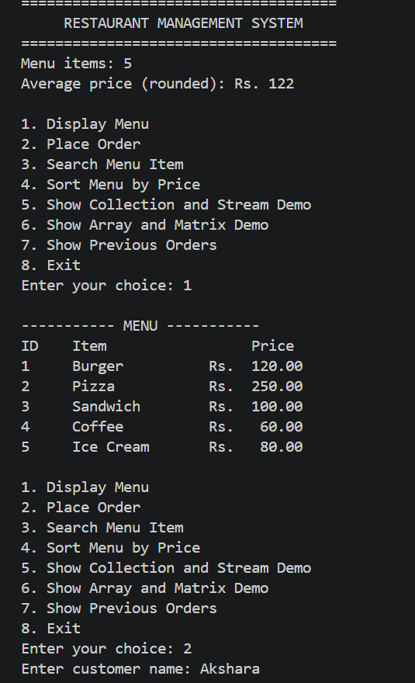

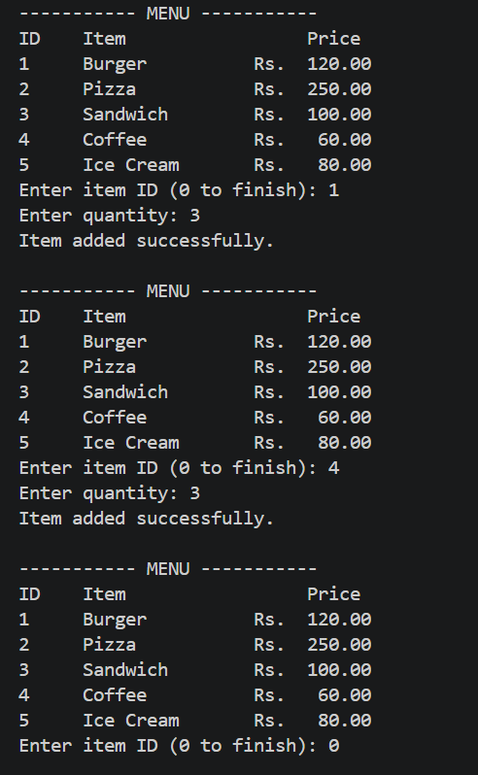

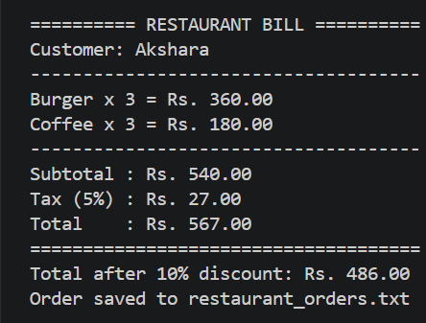

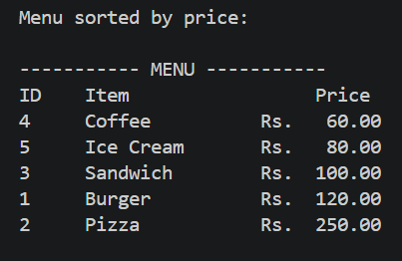

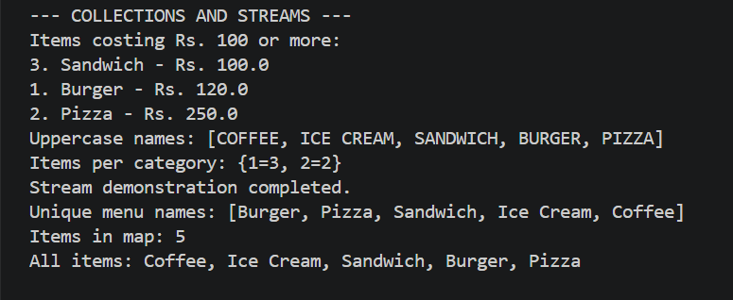

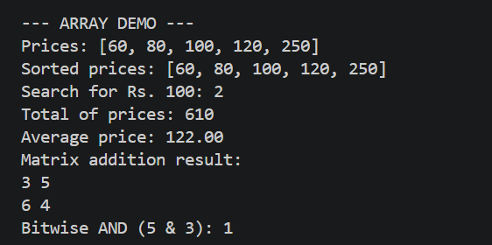

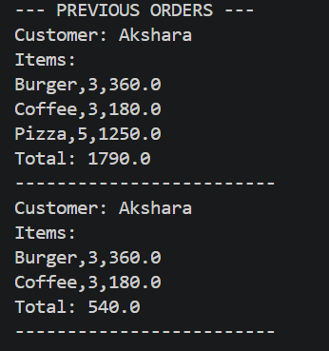

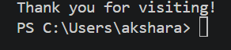

CONCLUSION:

The Restaurant Management System demonstrates a practical combination of Java programming concepts in a single console application. It supports menu viewing, order entry, quantity validation, billing calculations, searching, price sorting, and text-file order history. Its use of classes, inheritance, interfaces, method overloading, arrays, recursion, collections, streams, and exception handling makes it suitable for demonstrating several syllabus concepts through one project.
The current implementation is an educational prototype rather than a production restaurant system. For example, the order history is stored in a plain text file, and the 5% tax is currently calculated using a literal value instead of the declared TAX_RATE constant.

FUTURE WORK :
Develop a graphical user interface so staff can select items and manage orders more easily.
- Use a database to store menu items, customer details, and order history in a structured and searchable format.
- Connect the tax calculation to TAX_RATE and make tax and discount rules configurable.
- Add receipt printing, payment status, order numbers, and clearer separation between tax-inclusive totals and discounted totals.
- Improve input validation and add more robust handling for malformed or incomplete saved records.
- Add menu maintenance features such as adding, updating, or removing menu items.
- Introduce user roles and authentication if the project is extended for real restaurant use.
- Add automated tests for billing calculations, quantity validation, search, sorting, and file operations.

